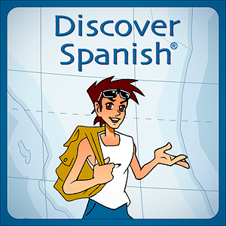

*Discover Spanish Lesson 33: The Restaurant Nombre:*

* *Begin with the “explore” tab.  Listen and repeat the phrases*
* *Continue with the “learn” tab.  Click next to the words to hear them, then repeat*
* *Use the button on the far right to move to the next “learn” page.  Continue to read and repeat on each page*
* *Go on to the “practice” tab.  Complete the activities and play the game.  
   Complete the questions for comprehension found below*
* *Copy your answers into a googledoc.  Share completed answers with me at* [*micahjohnson@claytonschools.net*](mailto:micahjohnson@claytonschools.net)

Comprehension questions:

A. Explore

1. ¿Qué pide (order) la señorita de la camisa morada?
2. ¿Tiene mucha hambre la pelirroja? ¿Por qué?
3. ¿Cómo se dice? Enjoy your meal:

B. Learn

1. Escribe en español:

vegetable soup: juice: chicken with rice:

1. How would you order two glasses of juice?
2. ¿Cómo se dice? I would like a bacon sandwich.
3. ¿Cómo se dice? Bring me the check, please.
4. What are three things a waiter may ask you? (en español)
5. ¿Qué pides tú cuando vas a un restaurante?